**Adding the Google Maps app to your Smart Builder Page**

Have you wondered whether or not it’s possible to embed a Google map onto your Smart Builder page? Well, wonder no longer, as it’s now just a few clicks away.

You’ll now have the ability to show your visitor where your store is based, where your office branches are located or inform potential buyers where that fancy apartment is you’re trying to sell.

#### Installing the Google Maps app

Once you’re inside the Smart Builder editor, you’ll want to add that Google Maps template to your page. Here’s how:

1. Navigate to the Apps tab within the left-hand side of the menu at the top of Smart Builder.
2. Scroll down to locate the Google Maps App.
3. Click the plus button next to the Google Maps App to install it:   
     
   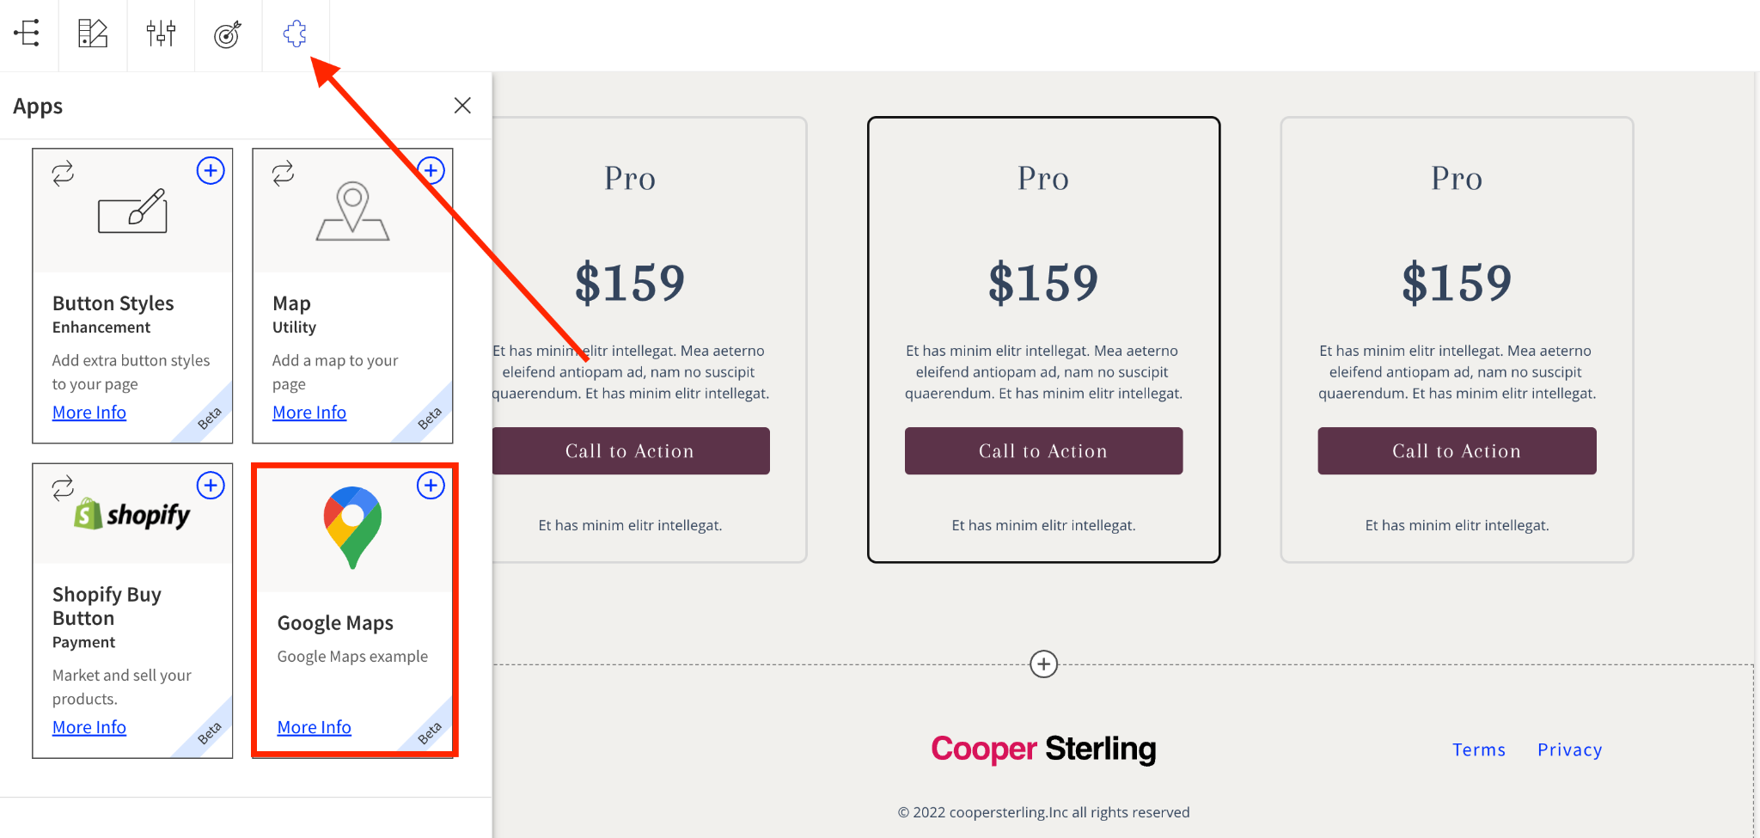
4. A window will appear, where you may choose a Google Maps section template:  
     
   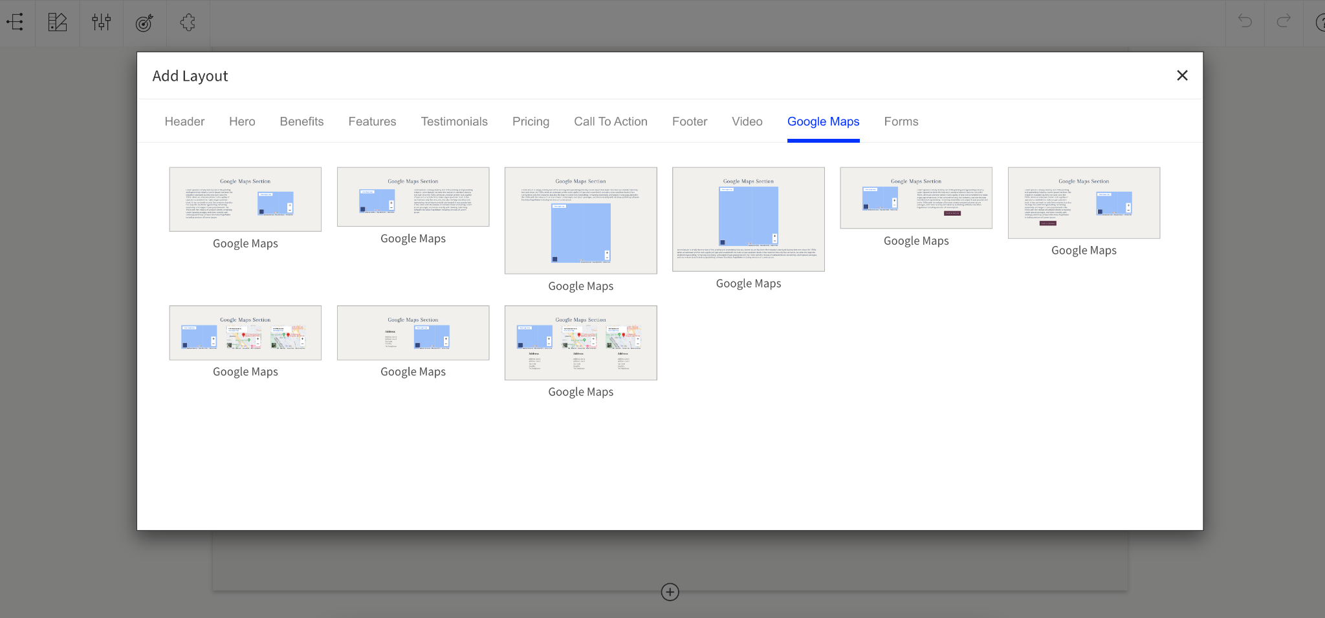  
     
   See our [documentation for more on Section templates](https://documentation.unbounce.com/hc/en-us/articles/4403350773012).
5. Once selected, the Google Maps section template will appear on the page for you to customize:

[](https://jmp.sh/v/WvI5YKlFgkeTFLF0zLBY)

1. Remember to save your page.

#### Customizing your Google Map

Now that you have selected your preferred template, we can move on to customizing the look and feel of your map.

1. Single-click on the map in your section, and select the Map Settings icon that appears below it. A pop-up will then appear.

[](https://jmp.sh/v/bmyHSHHRUmLa3TVPGyBg)

1. You can yype in the address of the location you want to show in the space provided.

[](https://jmp.sh/v/kn3oOZxlDt0CGXQOjeHg)

1. If you prefer to show a satellite view of the map, you can turn this on with the toggle button below: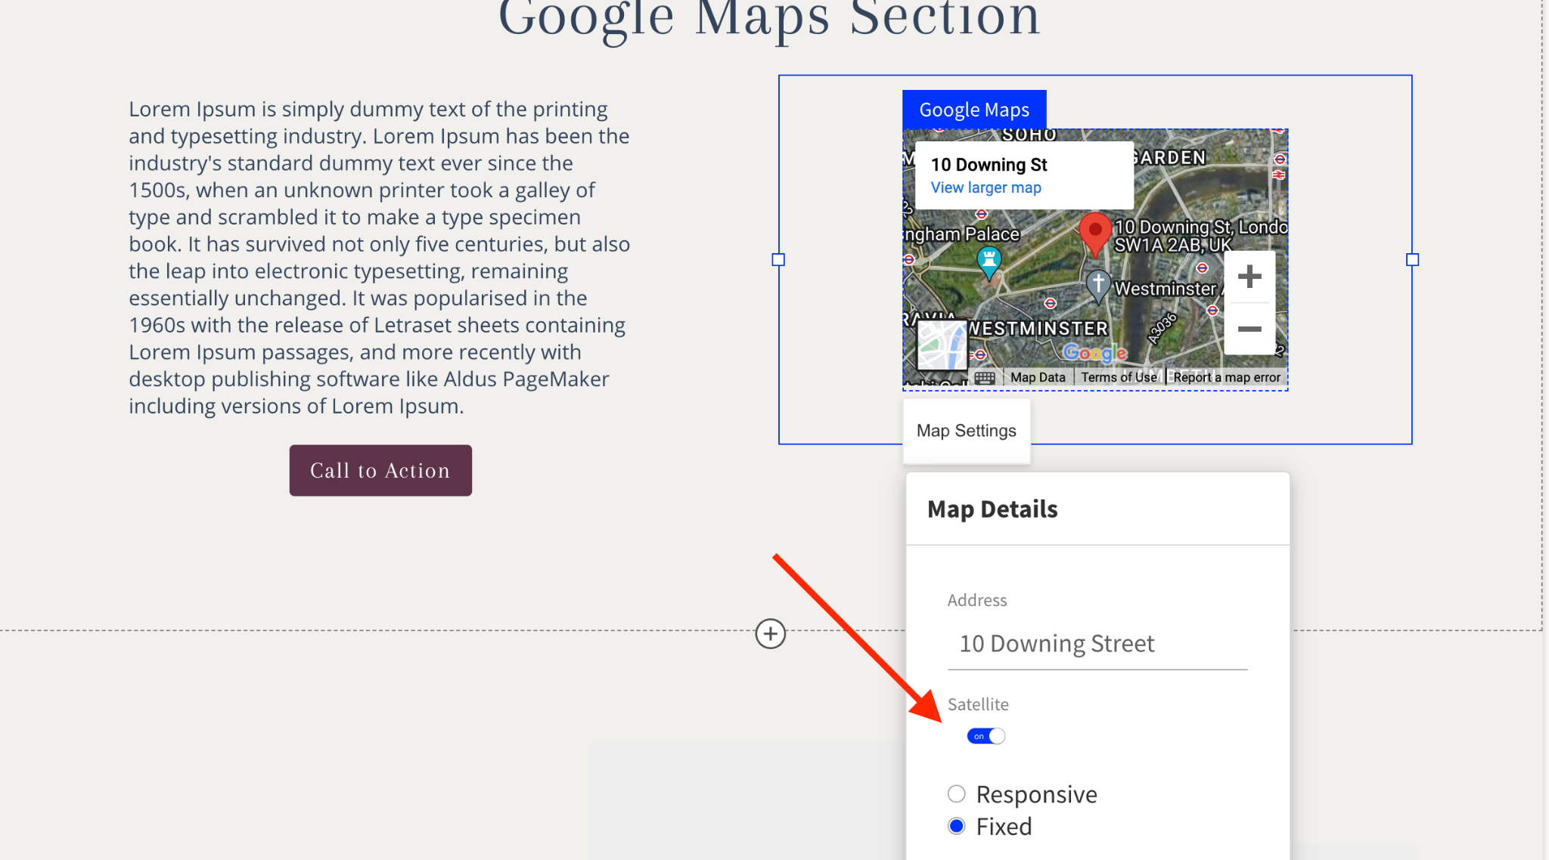

#### Modifying your Google Map size

The Map Settings also provide you with the flexibility to choose the size of your map, as well as how it is going to look on different devices. The sizing options allow you to choose between **Responsive** or **Fixed**.

#### Responsive

Selecting the responsive option means that your map will change size dynamically based on the type of device you are viewing the page with (e.g. smartphone, tablet, desktop). This will be the default setting for any Google Maps added to your page.

#### Fixed

Selecting the fixed option means that you can choose the specific width and height of your Google Map. This also means that the map size remains the same regardless of the device being used.

To fix the dimensions of your map, select the Fixed option in your Map Settings. Two new fields will now appear. This is where you can input the map width and height:

[](https://jmp.sh/v/Jgo72ZK8efnoaIWhYmcI)

Remember to save and publish your changes once you’re happy with them. Congratulations - you’ve just added your first Google Map to your landing page!